CS 583: INTRODUCTION TO COMPUTER VISION

FALL 2013

PROJECT 2: MOSAICING

In this project, I must implement a program to combine multiple images into a panorama. The program has to automatically align the input images by computing their relative motions and then blend the resulting tile of images into a single seamless panorama. Along the way, you will learn how to warp images into cylindrical coordinates and compute translational motion between images using a Gaussian pyramid.

The requirements of the assignment are:

1. Calibrate the camera and take images.
2. Warp each input image into cylindrical coordinates and output them.
3. Manually assign initial translation to each image.
4. Compute the alignment (translation) for each image pair using pyramid-based Lucas-Kanade motion estimation.
5. Stitch and crop the resulting aligned images (this includes blending and re-distribution of accumulated errors).
6. The Lucas-Kanade motion estimation can be unstable for different reasons. Try to make it robust. Explain what you did, why you did what you did, and show what difference it made.

**INPUT IMAGES**  
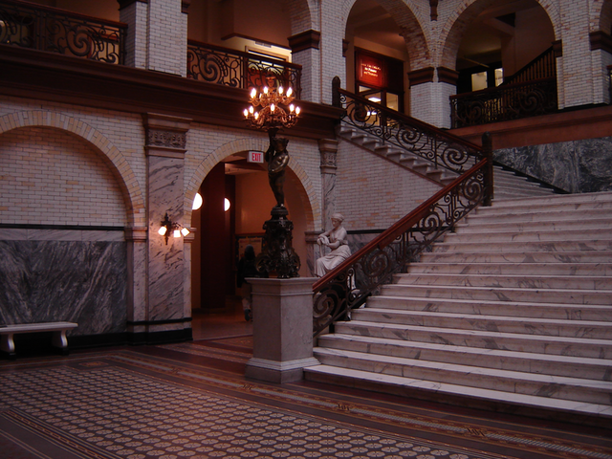

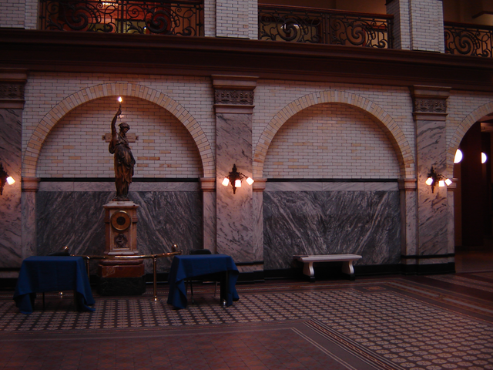 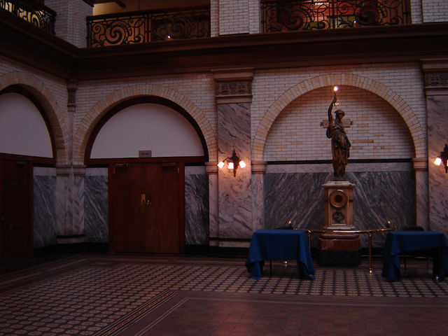

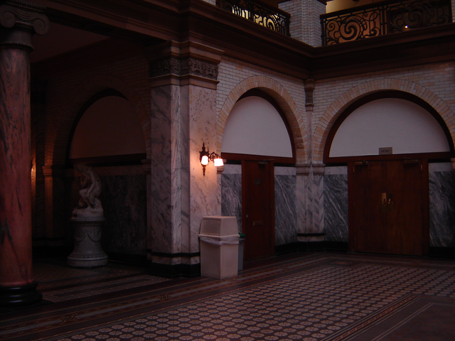 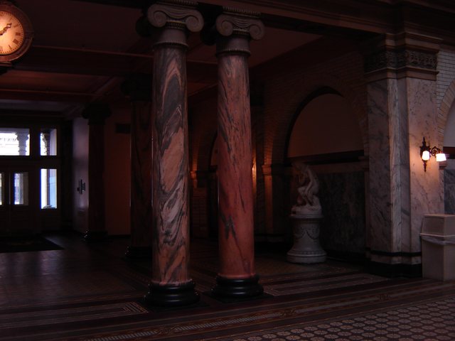

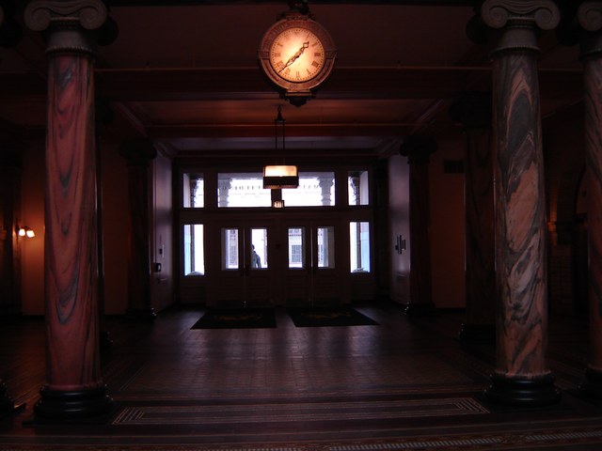 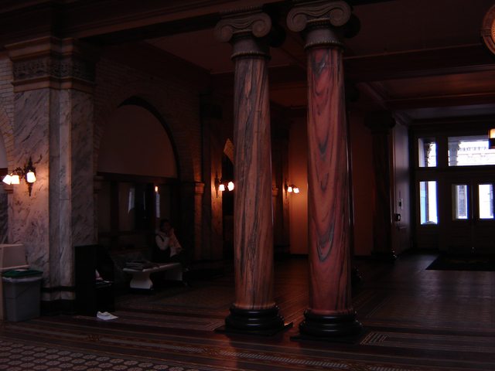

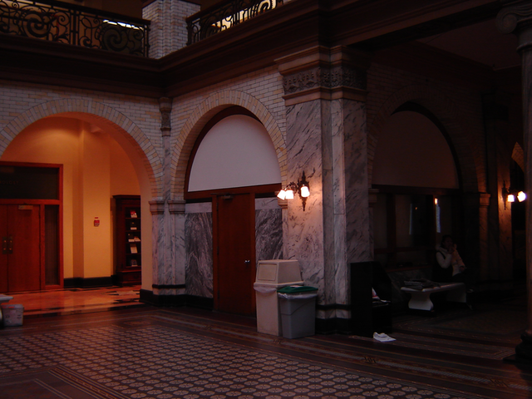 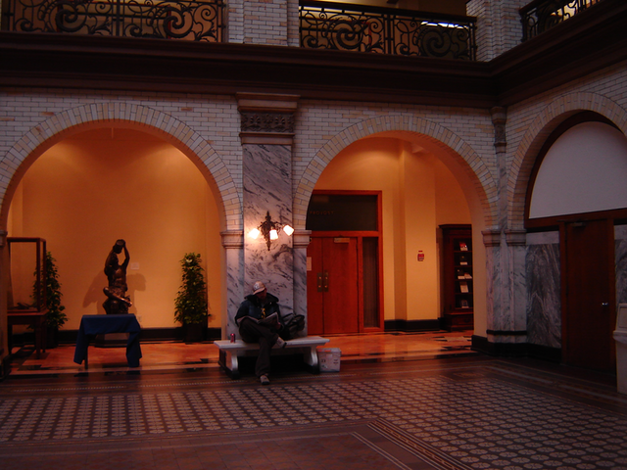

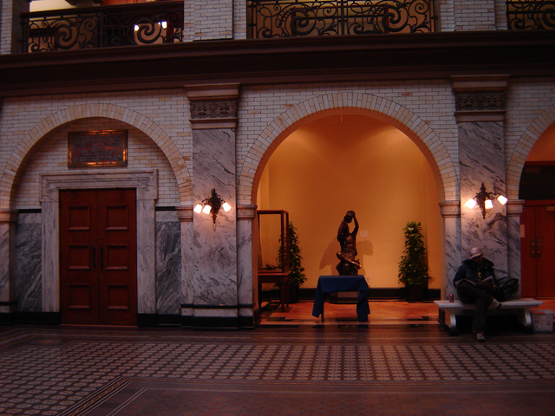 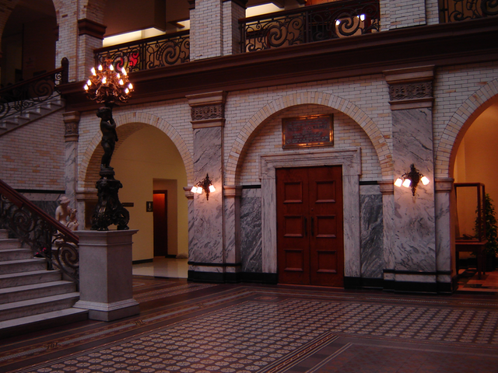

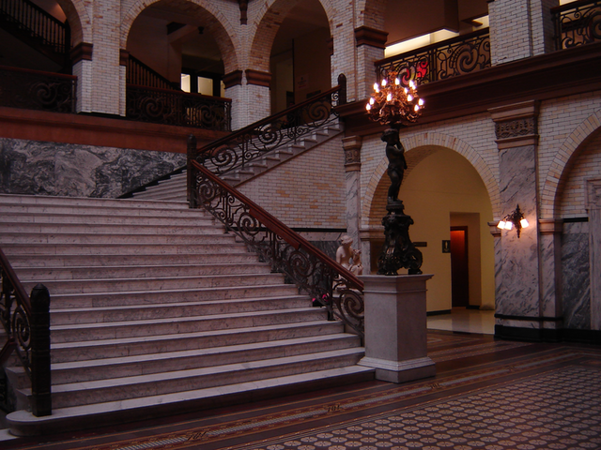 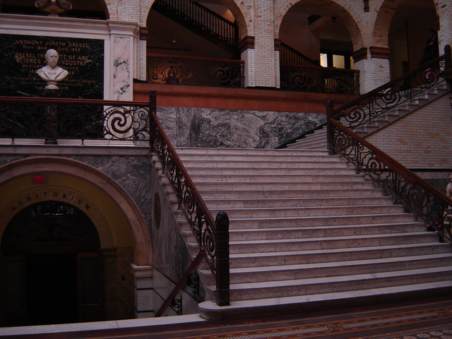

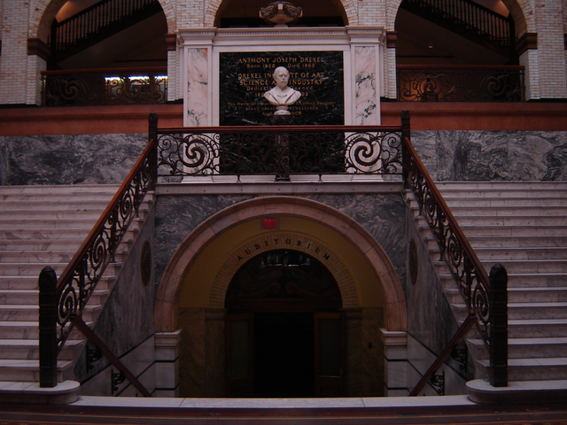 

**CYLINDRICALLY WARPED IMAGES**

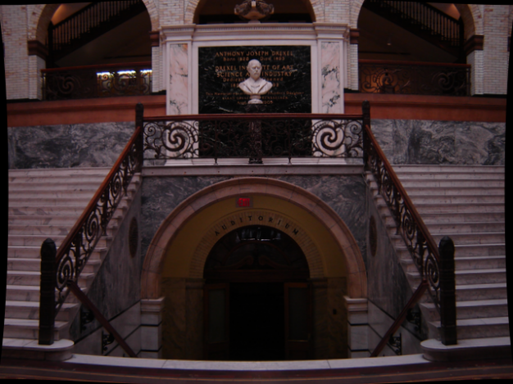 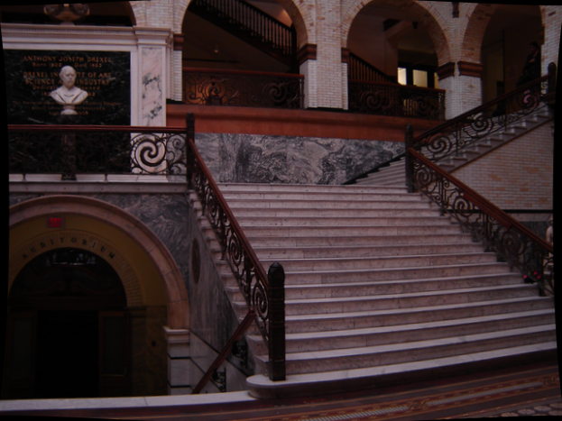

**TRANSLATED IMAGE**   
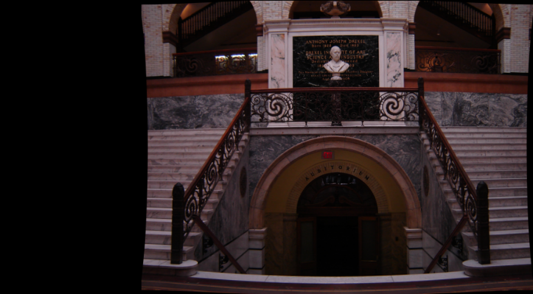

**PANORAMA**

